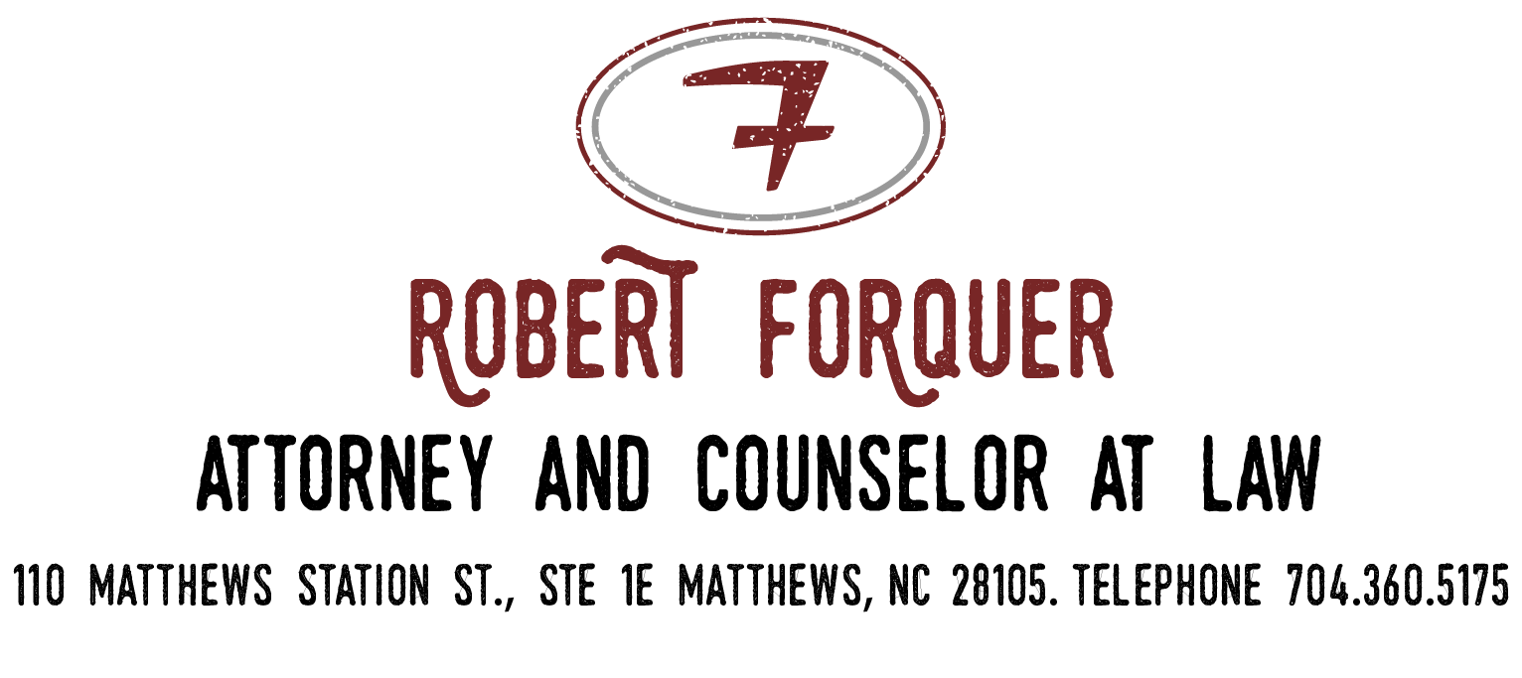
title search

BUYER/BORROWER NAME:
CURRENT OWNER NAME:
PROPERTY ADDRESS:
PARCEL ID NUMBER:
LENDING INSTITUTION (IF CASH N/A WILL SUFFICE):
LENDER CONTACT NAME:
LENDER CONTACT PHONE:
LENDER CONTACT EMAIL:
PROPOSED CLOSING DATE:

You are hereby authorized to furnish to The Law Office of Robert Forquer or any of its employees, including, but not limited to, Robert Forquer, Mark Lattimore, and Bryant Brown, a Title Search Order. You are also authorized to issue updates to any previously issued Title Search Order if necessary.
Please fax the mortgage payoff statement to Bryant Brown of the Law Office of Robert Forquer at 704- 498-4878. Alternatively, you may email it to bryant@forquerlaw.com.

