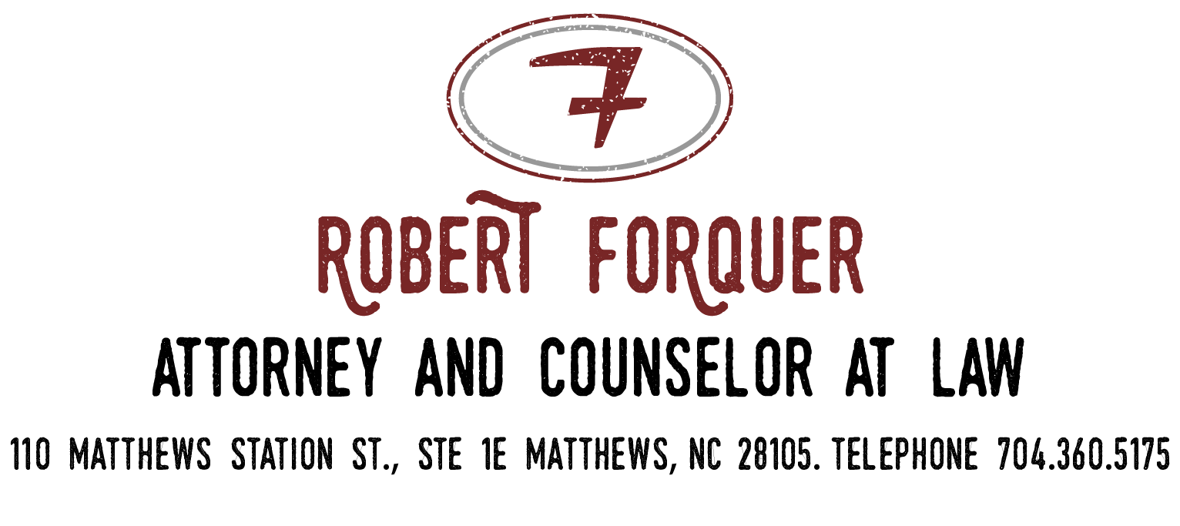
mortgage payoff authorization

MORTGAGE BEING SERVICED BY:
MORTGAGE COMPANY PHONE:
BORROWER/OWNER’S NAME(S):
PROPERTY ADDRESS:
ACCOUNT NUMBER:

You are hereby authorized to furnish to The Law Office of Robert Forquer or any of its employees, including, but not limited to, Robert Forquer, Mark Lattimore, and Bryant Brown, a mortgage payoff statement on the above captioned mortgage. You are also authorized to issue updates to any previously issued mortgage payoff statements, if necessary.
If this is a line of credit account, please take this authorization as notice to freeze further advances from my account for a period of 30 days from the date a payoff statement is issued.
Please fax the mortgage payoff statement to Mark Lattimore of the Law Office of Robert Forquer at 704- 498-4878. Alternatively, you may email it to mark@forquerlaw.com.

OWNER SIGNATURE:
OWNER NAME (PRINT):
DATE OF SIGNATURE:
OWNER SIGNATURE:
OWNER NAME (PRINT):
DATE OF SIGNATURE:

